IT24100680

Dewmith H.B.S.

PS_Lab06

1 i)

ii) 

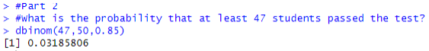

2 i)

ii)



iii) 

